Chapter 13, Solution 5.

  - If the coils are connected in series,

247.4 mH

  - If they are connected in parallel,
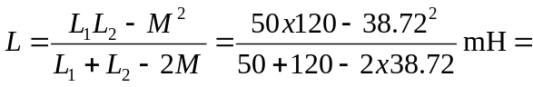 48.62 mH

(a) 247.4 mH, (b) 48.62 mH

